1. Weak interactions between algae, mayflies, and tadpoles suggest communities will have weak response to mountain yellow-legged frog extinctions.
2. Weak interactions between algae, mayflies, and endangered tadpoles
3. Herbivory and competitive effects of mountain yellow-legged frog tadpoles
4. Ecological roles of of endangered Mountain yellow-legged frog tadpoles

Thomas C. Smith†, Marina Bozinovic, Yishen Miao, Cherie J. Briggs

Department of Ecology, Evolution, and Marine Biology, University of California, Santa Barbara, California 93106 USA; phone: (805) 893-2888

†email: thomas.smith@lifesci.ucsb.edu

Author Contributions: Thomas C. Smith conceived the study, performed the research and analysis, and wrote the manuscript; Marina Bozinovic and Yishen Miao contributed to the research, analysis, and text, and edited the manuscript; Cherie J. Briggs contributed to study design, data analysis, and edited the manuscript.

Abstract

Worldwide declines of amphibian populations and loss of amphibian biodiversity have prompted investigations into the ecological functions of endangered and declining amphibian species and the consequences of their extinctions. In the Sierra Nevada of California, mountain yellow-legged frogs are nearly extinct, yet we have little quantitative explicit knowledge of their interactions with other species, especially for tadpoles. We performed two experiments to quantify top-down control of algae by tadpole grazing , and to quantify competition between tadpoles and mayflies. In field enclosures in two remote high elevation lakes, we manipulated the densities of tadpoles and mayfly nymphs in a response surface design, and replicated the experiment in three two-week blocks. Only mayflies display a negative effect on algal abundance. There was no indication that tadpoles experienced any competition, though increasing tadpole density may facilitate individual growth. Mayflies however, were subject to both interspecific or intraspecific competition, as they declined in size as densities of both consumers increased. To test the effects of consumers on algal abundance independent of variability within lakes, we performed a mesocosm experiment in which we manipulated the presence and absence of high densities of tadpoles and mayflies. Tadpole presence reduced algal abundance by about 50%, but did not reduce algal growth rate. Mayflies reduced algal abundance, but only when tadpoles were present. Taken together, our results suggest that extinctions of endangered mountain yellow-legged frog tadpoles may allow benthic producers to reach higher abundance and biomass, which could influence other consumers in lake communities. This highlights how the ecological effects of amphibian declines, or of any taxa, can be small and may be difficult to detect or quantify

Keywords: *Ameletus spp,* amphibian declines, *Callibaetis ferrugineus*, interspecific competition, *Rana muscosa/Rana sierrae,* response surface design, Sierra Nevada, top-down control

Introduction

Amphibians are declining in diversity and abundance worldwide (Stuart et al. 2004, Wake and Vredenburg 2008). These declines and extinctions of populations and species have the potential to alter the communities in which amphibians live (Paine 1966, Chalcraft and Resetarits 2003, Gruner et al. 2008, Dunne and Williams 2009, Connelly et al. 2014). One of the most direct ways in which amphibian declines will influence communities is in the loss of consumer biomass, potentially leading to release of top-down control of resources (Hairston et al. 1960, Carpenter et al. 1985) and to competitive release for other consumers (Holbrook and Schmitt 1995). The extent to which an amphibian affects its community by resource consumption may vary depending on the extent to which its resources are subject to top-down control (Shurin et al. 2002, Borer et al. 2005, Wollrab et al. 2012), its ability to reduce resource abundance, and the dependence of potential competitors on shared resources (Murdoch et al. 2003). These characteristics of consumers and communities probably vary greatly within the class Amphibia is (Duellman and Trueb 1994, Alford 1999). Predictions about the ecological effects of one amphibian species’ decline or extinctions, aside from those of the entire class, should be based on quantitative descriptions of its unique interactions and specific effects on communities.

Among amphibians, declines of the anurans, the toads and frogs, are generally the best understood; many anuran populations and species have been dramatically reduced in abundance or driven extinct by habitat destruction, over-exploitation, or disease, if (Stuart et al. 2004). These declines have the potential to affect communities and ecosystems, because anurans, and especially their tadpoles, can be ecologically important in their respective communities (Alford 1999). Many tadpoles are benthic grazers, and can reduce the abundance of benthic producers (Kupferberg 1997a, 1997b, Alford 1999, Connelly et al. 2008, 2014). In experiments, Common frog tadpolessuppressed periphyton biomass 60-85% (Brönmark et al. 1991). Tailed frogs in Pacific Northwest streams consumed 98% of algal biomass on experimental tiles (Lamberti et al. 1992). In northern California rivers, California red-legged frog tadpoles can graze epiphytic diatoms to abundances low enough to facilitate growth of underlying vegetation (Kupferberg 1997a).

This ability to control resources means that tadpoles also have the potential to be strong exploitative competitors. Invasive American bullfrog tadpoles in northern California rivers reduce algal abundance and cause declines in native California red-legged frog and Pacific treefrog tadpoles; these two native species also competed via exploitation, both intra- and interspecifically (Kupferberg 1997b). . The presence of Common frog (*Rana temporaria*) tadpoles, grazing the preferred food of co-occurring snails in Swedish lakes, can reduce snail growth rate and fecundity (Brönmark et al. 1991). Where California red-legged frog (*Rana draytonii*) tadpoles were excluded, mayfly nymphs and chironomid larvae were more abundant probably because epiphytic diatoms were more abundant as well (Kupferberg 1997a).

Furthermore, the ecological interactions of tadpoles and their resources and consumers are not limited to top down and exploitative interactions. Tadpoles can compete through interference (Steinwascher 1978, Kiffney and Richardson 2001)are subject to interspecific competition (Morin et al. 1988) and predation (Pilliod 2002), but can also facilitate insects by uncovering grazable benthic material (Ranvestel et al. 2004).

This evidence suggests that tadpoles, as a group, have the potential to influence the resources and other consumers in their communities. Tadpoles of the endangered mountain yellow-legged frogs (*Rana muscosa* and *R. sierrae*) of the Sierra Nevada fill ecological roles the loss of which has the potential to alter whole lake communities. Mountain yellow-legged frog tadpoles are grazers of benthic algae, and are potential competitors with mayfly nymphs, caddisfly larvae, diptera larvae, and other benthic macroinvertebrates.

Mountain yellow legged frog tadpoles may also have been ecologically important because of their abundance and their ubiquity. They once commonly reached densities of 60 tadpoles per meter of shoreline in lakes (Roland A. Knapp, personal communication) along both sides of the Sierra Nevada mountains and in streams in the Transverse Ranges of southern California (Vredenburg et al. 2007). Dramatic declines in the range and abundance of frogs and tadpoles were driven initially by predation by stocked non-native trout (Knapp and Matthews 2000). Despite the cessation of stocking, populations continue to be threatened by the emergence and spread of the amphibian chytrid fungus, *Batrachochytrium dendrobatidis* (Briggs et al. 2005). Now, large frog (and tadpole) populations are limited to a handful of populations in extremely high elevation lakes in Yosemite and Sequoia/Kings Canyon National Parks and the adjacent John Muir Wilderness in the southern Sierra. In most lakes in the Sierra Nevada, mountain yellow-legged frogs and tadpoles are now locally extinct (Briggs et al. 2010, Vredenburg et al. 2010)..

To explore how these declines and local extinctions might affect Sierra Nevada lake communities, our objective was to quantify tadpoles’ impacts on their resources and on potential competitors. In Sierra Nevada lakes, tadpoles feed on algae (epiphyton largely composed of diatoms, also containing some cyanobacteria, green algae, chrysophytes, and other microbes). We chose to study mayfly nymphs as potential competitors because they can also suppress algal abundance (Hill and Knight 1987, Morin et al. 1988, Dudley 1992, Hertonsson et al. 2007) and are abundant in Sierra Nevada lakes (Bradford et al. 1998, Epanchin et al. 2009). We predicted that in the presence of tadpoles, algal abundance would be lower, and that higher densities of tadpoles would reduce algal abundance more. In addition, mayflies would also reduce algal abundance, and tadpoles and mayflies together would reduce algal abundance additionally. We also predicted that average body sizes of each consumer would decline along with increasing consumer densities. To investigate these predictions, we performed an *in situ* field enclosure experiment and a mesocosm experiment. The results of these experiments clarify the role of mountain yellow-legged frog tadpoles in Sierra Nevada lakes, and sheds light on how their extinctions might affect communities.

Methods

Experimental methods

We performed two experiments, a field experiment and a mesocosm experiment. Our field experiment allowed us to describe, within the natural setting of two remote high elevation lakes, the interactions between two consumers: tadpoles (*Rana muscosa* and *Rana sierrae*) and mayfly nymphs (Ephemeroptera, *Callibaetis ferrugineus* and *Ameletus spp.*), and their shared resource, benthic organic matter. This consists largely of diatoms but can also include green algae, cyanobacteria, chrysophytes, detritus, bacteria and other microbes; because of the dominance of diatoms and producers, we refer to it hereafter as algae. In the mesocosm experiment, we tested the effects of the same grazers (*Rana sierrae* and *Callibaetis ferrugineus*) on algal resources, in artificial habitats which eliminated the natural nutrient, temperature, and substrate heterogeneity found within most lakes.

*Field enclosure experiment. –* In the field enclosure experiment, we used a response surface design (Inouye 2001) to characterize the independent and interactive effects of grazers. Response surface designs facilitate description of intra- and interspecific interactions, as they allow two factors to vary alone and together. For each of our two consumers, we established four treatment levels, including the absence of and three density levels of each, the highest of which was set by the highest densities of these two consumers we have observed in amphibian surveys and invertebrate community surveys (Roland A. Knapp, personal communication, and Smith et al., in review). Tadpole treatment levels were 0, 2, 10, and 20 individuals, while mayfly treatment levels were 0, 25, 125, and 250 individual mayflies. Each treatment was a combination of two of these treatment levels, and was replicated once in each of two lakes, except the zero-tadpole/zero-mayfly treatment which was replicated twice in each lake (total n = 34). Because we could not replicate treatments physically, we replicated the experiment in time in three blocks.

The two study lakes were remote high elevation lakes in the Kings Canyon National Park backcountry, referred to as LeConte (3221 m elevation, 37°06'58.78" N 118°38'40.16" W) and Spur (48 km to the southeast of LeConte, 3518 m elevation, 36°43'47.49" N 118°23'38.33" W, Google Earth 2014). Both lakes lie close to and west of the Sierra Nevada crest. They are small alpine lakes, however while LeConte is surrounded by small meadows, white bark pine and willow, talus, and bare bedrock, Spur is in a basin devoid of vegetation and is surrounded by mostly talus and minimal bare bedrock. The water in these lakes has low nutrient concentrations and circumneutral pH: nitrate 0 – 10 μmol L-1, total phosphorus 0 – 1 μmol L-1 (Sickman et al. 2003); median pH ≅ 7 (Bradford et al. 1998). We selected these two lakes because both had large, disease free cohorts of mountain yellow-legged frog tadpoles (R.A. Knapp, personal communication) and large mayfly nymph populations, were relatively accessible, and not in areas frequently used by backpackers.

Seventeen enclosures were placed in each lake, along the shoreline in the littoral zone where tadpoles feed during the day. Enclosures were 0.5 m wide x 0.5 m tall at one end and 0.5 m wide x 1.5 m tall at the opposite end, and were 2 m long (1 m2 on the bottom). Each was oriented perpendicular to the shoreline, so that the tall end sat in deep water, and the short end sat along the shoreline (Fig. 1). This wedge shape allowed tadpoles to use deep and shallow water. Enclosures were partially submerged so an air space remained in the top of each enclosure to accommodate emerging mayflies, and one rock from outside the lake was placed inside each enclosure to accommodate metamorphosing tadpoles. Enclosures were supported by a light weight steel frame (Sturdy Stake #ST6 www.homedepot.com) and guy-lines, and were constructed from plastic mesh fabric, with pore size approximately 250 μm (Nitex: e.g. SKU 24-C44 www.wildco.com; polyester organza, various sources). This mesh size prevented escape of mayflies and tadpoles, and prevented invasion by other benthic macroinvertebrates, but allowed movement of water, sediment, phytoplankton, and small zooplankton (mostly Copepoda).

We captured tadpoles and mayflies in each study lake. We captured tadpoles throughout both lakes and after weighing and staging them (Gosner 1960), included those between Gosner stage 26 and 41. In LeConte, tadpoles were *Rana sierrae*; in Spur tadpoles were *Rana muscosa* (Vredenburg et al. 2007). We captured mayflies in the littoral zone of the lakes using benthic sweeps of a standard D-net (mesh size 250 μm), and separated mayflies from other invertebrates in a sorting pan using flexible forceps and a turkey baster. While mayflies were not chosen based on instar, we included only those without wing-pads when possible. In LeConte, mayflies were virtually all *Ameletus spp.*, but in Spur, *Ameletus spp.* and *Callibaetis ferrugineus* were present in equal proportions. When tadpoles were older than stage 38 at one visit, they were removed to prevent metamorphosis prior to the next visit; each removed individual was replaced with a younger tadpole. Similarly, adult mayflies which emerged from the nymph stage were replaced by younger individuals.

Algal growth in each enclosure was measured from unglazed porcelain tiles placed on the bottom of each enclosure (two sets of 12 porcelain tiles, each 2.4 cm x 2.4 cm, 140 cm2 total area per enclosure). To account for potential variation in algal growth due to unquantified within lake variation in nutrient concentrations, temperature, currents, or aspect, we established a no-consumer within-lake-location control for each enclosure by placing a set of tiles in a small bag made of the same mesh as enclosures, and setting it in the littoral zone next to each enclosure (Figure 1). We also recorded substrate type below and light within each enclosure. Substrate was described as percent of the substrate below each enclosure which was composed of silt (defined as particles < 0.5mm, as in Knapp and Matthews 2000). Solar radiation (photosynthetic photon flux) was measured within each enclosure at the water surface using a basic quantum meter (Apogee Instruments, Logan, UT).

Experiments began in the early ice-free season (17 July 2009 in LeConte and 21 July 2009 in Spur), and ran in three blocks, which lasted 16-21 days. At the start of blocks two and three, we completely cleaned tiles, and restocked grazers to their initial treatment densities. At the conclusion of each block, we sampled algal abundance, mayfly nymph abundance, emerged adult mayfly abundance, tadpole abundance, gosner stage, and wet weight. These were used as response variables, or to calculate response variables.

Algae abundance was calculated for each enclosure on each sampling date. We collected algae samples from enclosure tiles and from within-lake-location control tiles, for later determination of ash-free dry mass (AFDM). In the field, algae was scrubbed from tiles using a soft-bristle toothbrush, and suspended in 60 mL of water. Suspended algae were collected on a glass fiber filter with 1.2 μm pore size, using a hand powered vacuum pump. Filters were wrapped in foil and stored in a cool dark place (under a boulder) in the field until they could be frozen in the lab for later processing. Filters were dried at 105 C for at least 24 hours, weighed, combusted at 500 C for 1 hour, then weighed again. Ash-free dry mass was calculated as the difference between filter-plus-sample weights before and after combustion (Hauer and Lamberti 2007). When less than 60 mL of suspension had been filtered, we multiplied the measured AFDM by the fraction of 60 mL that was filtered.

At the conclusion of each block, we counted, weighed, and staged tadpoles. At the conclusion of the entire experiment, all tadpoles were weighed and staged a final time, and released back into the lakes. In order to calculate a Gosner stage-mass regression for tadpoles, we collected, euthanized and preserved in 10% formalin 37 tadpoles from a non-study lake (Marmot Lake, 3590 m elevation, 37°15'36.33" N 118°41'01.38" W). The tadpole samples were collected to serve as a model for ash free dry mass. The lengths of the tadpoles were measured and the gut contents of the tadpoles were removed in order to be inspected. We placed the remains in foil boats and weighed the unit before combustion. The boats were then placed in a drying oven set at 105° C for 24 hours. After that period, we reweighed the boats and placed them in a combustion oven at 500° C for one hour.  Once the samples were weighed in their boats, we discarded of the remains and weighed the foil boats by themselves. When we subtracted this weight from the unit, we were able to measure AFDM for each specimen, which was calculated to the nearest 0.1 mg.

The ADFM values from the non-experimental tadpoles from the field were used in conjunction with the lengths of the tadpoles to construct a linear regression with a best fit line. Thirty ADFM values from the tadpoles were graphed against their respective Gosner stages to produce a length-mass relationship. The line best fit to describe the data was a power function that showed an upward trend. We then applied this function to a set of Gosner stages in order to output a set of predicted ADFM values. These values, based on the power function, were associated with Gosner stages of tadpoles taken from the field. The corresponding predicted AFDM was used to find means and standard deviations of each lake from each date.

At the conclusion of each block, we counted mayfly nymphs, and counted and collected emerged adult mayflies. At the conclusion of the entire experiment, all mayflies were collected and preserved. We measured nymph to the nearest 0.1 mm under 10 x magnification, using graticules in the eyepieces of a stereoscope ([insert model info here]); we did not simultaneously quantify instars of individuals. To calculate a length-mass regression relationship for mayflies, we collected a sample of mayflies from each lake. These mayfly nymphs were preserved in ethanol, then measured, dried at 105 C for 24 hours, weighed, combusted at 500 C for 1 hour, and weighed again; ash free dry mass was calculated as the difference between the two weights (Hauer and Lamberti 2007). Ash free dry mass was calculated as it was for algal samples.

We plotted non-experimental tadpole and mayfly AFDM data with respect to tadpole Gosner stage or mayfly length, and fit regression lines to these data (e.g. Sabo et al. 2013). To estimate experimental tadpole and tadpole and mayfly biomasses from the easily measured stage or length, we used the formulae of the size-AFDM regression lines to calculate estimated AFDM of each individual experimental tadpole and mayfly.

*Mesocosm experiment. –* We also conducted a mesocosm experiment to further explore the effects of tadpoles and mayflies on algal resources, without the environmental variability that occurs throughout lakes. We used a 2 x 2 factorial design, with treatment levels for presence and absence of tadpoles and mayflies, arranged randomly among four blocks. Four mesocosms contained zero consumers, four contained16 tadpoles, four contained 250 mayflies, and the remaining four contained 16 tadpoles and 250 mayflies (n = 16).

Mesocosms were located at the Sierra Nevada Aquatic Research Laboratory near Mammoth Lakes, CA (2165 m elevation, 37°36'50.83" N 118°49'57.56" W). We used sixteen cube shaped (1 m3) concrete tanks lined with Thoroseal concrete sealer, with sloping, partially submerged shelves on the south facing side to allow tadpoles and metamorphs to bask (Fig.1). These tanks were filled with water from adjacent Convict Creek; nitrate and phosphate levels in Convict Creek are similar to those observed in most Sierra Nevada lakes, and while pH is higher than most Sierra Nevada lakes (pH 7.9 – 8.5) it is in the range tolerate by mayflies and tadpoles in lakes (pH 6.5 – 8.5) (LELAND et al. 1989, Bradford et al. 1998, Sickman et al. 2003). Creek water was the source for algae, and mesocosms were filled in April 2010 to allow algae communities to develop prior to the introduction of consumers. Each mesocosm contained thirty sets of twelve porcelain tiles (similar to those used in the field enclosures, each tile was 2.4 cm x 2.4 cm, total area of 12 tiles x 30 sets of tiles: 2074 cm2) to provide standard surfaces on which we could measure algal abundance; twenty five were placed on the bottom of each mesocosm, and five were placed on each shelf (Fig. 1).

We collected 160 *Rana sierrae* tadpoles (Gosner stages 34-39) from Marmot Lake (John Muir Wilderness, 3590 m elevation, 37°15'36.33" N 118°41'01.38" W) and transported them in one gallon containers with portable aerators and surrounded by blocks of snow. About 3000 mayflies (*Callibaetis ferrugineus*) were collected from a small pond in Yosemite National Park (2608 m elevation, 37°53'07.18" N 119°23'39.97" W) using a D-net with 250 μm mesh size, sorted using 250 μm sieves, pipettes, and turkey basters, and transported similarly to tadpoles.

The experiment began in late July 2010 when we added consumers to the mesocosms. We were not able to maintain the mayfly densities, because mayflies were surprisingly undetectable in the mesocosms, and therefore experienced high mortality without our knowledge. Tadpole density was maintained by adding younger tadpoles to replace individuals which metamorphosed and were removed. We ended the experiment when so many tadpoles metamorphosed that we could no longer maintain tadpole densities in the mesocosms. We then measured size (tail width, and body length not including tail length) and developmental stage (Gosner stage) of at least 10 tadpoles from each mesocosm. We sampled each mesocosm for mayflies using the same D-net used to collect them, sampling until 10 consecutive sweeps collected no more mayfly nymphs. Mayflies were counted, but not measured.

In the mesocosm experiment, we sampled algal abundance four times: once prior to the start of the experiment in July, then three more times during July and August 2010. On each date, we sampled bottom tiles and shelf tiles. Tiles on the bottoms of mesocosms were exposed to grazing for one, two, and three weeks; in week 1, 15 tiles were removed from mesocosms, sampled for algae, and replaced. In week 2, five previously sampled tiles were removed, sampled again, and replaced. In week 3, at the end of the experiment, all remaining tiles were removed and sampled. Four out of five tiles on the shelves were sampled on the first and second date and replaced; all five were sampled at the end of the experiment. For all tiles, we scrubbed algae from each tile, suspended it in 60 mL of water, and filtered the suspension onto a glass fiber filter, using an electric vacuum pump. These samples were frozen immediately, and later processed for AFDM as described above. When less than 60 mL of suspension were filtered, we multiplied the AFDM by the fraction of 60 mL that was filtered.

Analytical methods

*Analysis of field enclosure experiment. –* For our analysis of field enclosure algal abundance data, we used two sets of independent variables in alternative analyses. In the first analysis the two independent variables were the categorical variables mayfly density and tadpole density, with four levels for each density treatment of each consumer. We also included categorical covariates for experimental block, with three levels, and for lake, with two levels (LeConte and Spur). The lake covariate accounted for differences between lakes such as elevation, temperature, or size. We also included continuous covariates for duration of experimental block (days), solar radiation within enclosures, and substrates beneath enclosures.

Alternatively, instead of using the categorical variables for mayfly and tadpole density, we used total biomass estimated for each consumer within each enclosure. For mayflies, per-enclosure AFDM was the sum of estimated individual AFDM calculated from the lengths of mayflies and the length-mass regression relationship. For tadpoles, per-enclosure total AFDM was based on the Gosner stage-mass relationship and stages we observed for each tadpole. These consumer biomasses were used as continuous independent variables in our second analyses, with the same covariates described above.

Our response variable of interest was algal abundance (algae AFDM m-2), measured at the conclusion of each block. We used linear mixed effects models (Zuur et al. 2009) to test the effect of consumer density and consumer biomass on algal biomass, with the response variable algal abundance, predictor variables tadpole and mayfly abundance or biomass, and covariates siltiness, radiation, duration of block, lake, and block. We included an interaction term between consumers, because of the potential for tadpoles to either facilitate or interfere with mayfly grazing. To meet the assumption of normality of residuals (Zuur et al. 2009), we log transformed algal biomass. We compared models that included random intercepts (for block and for lake), random slopes for consumer effects in different lakes, and allowed variance to differ among experimental blocks, lakes, and levels of mayfly and tadpole density (Zuur et al. 2009). To account for within lake variability in algal abundance, we calculated a second response variable, by subtracting algal abundance in enclosures from the algal abundance on within-lake-location control tiles (e.g. AFDMLocation Control – AFDMEnclosure), and we repeated the analyses.

To examine the effect of intraspecific or interspecific or competition on mayfly size, we fit the average length of mayflies at the end of the last block, to generalized least squares models in order to determine the factors to which mayfly body length responds. These models included tadpole density, mayfly density, block, a lake and mayfly species interaction, and allowed the variance of mayfly length to differ across the gradient of tadpole density and between mayfly species.

We analyzed tadpole biomass, using per-enclosure average predicted AFDM, to indicate intraspecific and interspecific competition. Our linear model included tadpole density, mayfly density, lake, block, and a tadpole density x lake interaction. We included this interaction because preliminary plots suggested that the slopes of the relationship between tadpole biomass and density differed in each lake. The model also allowed for random intercepts and difference variances in tadpole biomass for each block.We tested for normality of residuals of models of tadpole biomass data using a Shapiro-Wilk normality test, and examinedit graphically to determine normality.  We also tested for heterogeneity of variance by visually assessing boxplots of residuals with respect to tadpole density, lake, and block. To further explore the interaction between tadpole density and lake, we repeated this analysis of tadpole biomass, but separately for tadpoles from each lake.

*Analysis of mesocosm experiment. –* In our analyses of mesocosm algal abundance, the independent variables were tadpole abundance and mayfly presence;. We included an interaction term between consumers, because of the potential for tadpoles to either facilitate or interfere with mayfly grazing. We used a similar approach to fitting linear models as outlined above. We included covariates for duration of algal growth (days) and for the initial abundance of algae (log AFDM) in each mesocosm. We allowed variance to differ with respect to consumer presence-absence or abundance. We analyzed only tiles from the bottom of the tank. Due to the high mortality of mayflies, we repeated this analysis using final mayfly abundance rather than mayfly presence-absence.

We also calculated the growth rate of algae in the experiment, using the initial July algal abundance from each mesocosm as the time-zero abundance, the measured week 1 or 3 algal abundance as the time-one abundance, and the days between the beginning of the experiment and relevant sample date as the growth period. This growth rate was analyzed using generalized least squares models, similarly to the procedure described above. All analyses were performed using R (The R Foundation for Statistical Computing 2012).

We also analyzed mayfly length as a response to tadpole presence and mayfly presence or final mayfly abundance, in the mesocosms.

Results

*Field enclosure experiment. –* Tadpoles and mayflies had negative, but equivocal effects on the abundance of algae in field enclosures (Figure 2). Effects were more distinct in LeConte; the effects of both consumers were more variable in Spur (Figure 3). The best fit linear model (Table 1) of the raw algal abundance used log-transformed raw algal abundance to meet the assumption of normality of model residuals. The best-fit model included a random intercept for experimental block, which allowed mean algal abundance to differ among blocks; lake, tadpole density, and mayfly density were fixed effects (Table 2). Repeating the analysis using consumer biomasses, rather than densities, produced essentially the same result.

When we analyzed algal abundance controlledfor within-lake variability, only mayflies had a negative effect on algal abundance. The best fit linear mixed effects model of within-lake-variability controlled algal abundance (Table 3) included fixed effects for mayfly density, duration of block, and a random intercept that allowed the controlled algal abundance to differ with respect to experimental block, nested within lake, and allowed variance of controlled algal abundance to differ among experimental blocks and between lakes (Table 4, Figure 4).

Increased tadpole density was associated with higher average individual biomass in LeConte, but was not so in Spur (Figure 6). The best fit linear mixed effect model included an interaction between tadpole density and lake, as well as random intercepts and different variances for sampling blocks (Table 6). Separate linear mixed effect models for each lake clarified the interaction, illustrating that tadpole density enhanced tadpole biomass only in LeConte (Table 7). The coefficient for tadpole density in this model suggests that, in LeConte, 4 tadpoles can increase the biomass of a tadpole by 1 mg. Mayfly density did not affect tadpole biomass.

In the field enclosures, higher tadpole and mayfly densities reduced body length of mayfly nymphs (Figure 5). Tadpole presence reduced mayfly length by 6-17% in *Ameletus spp.* in LeConte, but had no effect on either species in Spur. Higher mayfly density reduced mayfly length by 8-23% for *Ameletus* *spp*. in LeConte, and 8-10% for *C. ferrugineus* Spur. Because of the difference in mayfly species relative abundance in the two lakes, the best fit generalized least squares model included an interaction between lake and mayfly species; this model also allowed for different variances of mayfly length across the gradient of tadpole density and between the two species (Table 5). While mayflies differed in size between LeConte and Spur, this may have been due to differences in phenology; we did not quantify instars of mayfly nymphs, so we cannot address that difference.

*Mesocosm experiment. –* In the 2010 mesocosm experiment, tadpole presence alone reduced algal abundance by 50% (Figure 7). Mayfly presence did not reduce algal abundance, The best-fit model included fixed effects for tadpole presence, duration of growth, and the initial abundance of algae, and allowed variances to differ between tadpole presence-absence (Table 8). Mayfly presence-absence was not included as a fixed effect in this model. We found no difference among growth rates of algae among consumer treatments (ANOVA, F3,28 = 0.0011, p < 1.0) (Figure 8).

In the mesocosms, mayfly nymph abundance declined by 48% – 100% during the experiment. Live mayflies recovered from mesocosms at the conclusion of the experiment were not near metamorphosis (they did not have wingpads), nor were exuvia or emerged adults ever observed. This apparent mortality was independent of coexistence with tadpoles; despite a trend towards larger declines in mayfly abundance in the presence of tadpoles, the difference was not significant (ANOVA, F2,6 = 0.338, p = 0.58). When we represented mayflies in the mesocosms by their final abundance, rather than presence-absence, the presence of tadpoles affected the outcome: algal abundance increased weakly with mayfly abundance in the absence of tadpoles, but, algal abundance declined with mayfly abundance in the presence of tadpoles (Figure 7). The best fit model of algal abundance, with respect to tadpole presence-absence and mayfly abundance, included fixed effects for a tadpole-mayfly interaction, duration of algal growth, and initial algal abundance, and allowed the variance of algal abundance to differ with tadpole presence-absence (Table 9). .

Discussion

Overall, we found strong to no effect of mountain yellow-legged frog tadpoles on algal resources and mayfly competitors (Table 10). Mountain yellow-legged frog tadpoles can reduce the abundance of algae in mesocosms, however, they had no effect on algal abundance in field enclosures, suggesting that the ability of tadpoles to exert top-down control of algal abundance can be obscured by within-lake variability in algal abundance. Tadpole did compete with with mayfly nymphs, as suggested by the association of increased tadpole density with reduced average size of individual mayfly nymphs in the field enclosures. On the other hand, tadpoles appeared to facilitate mayfly feeding in the mesocosms, as mayflies only had a negative effect on algal abundance when tadpoles were present. Tadpoles may also facilitate their own growth, as we observed that average tadpole biomass was higher at high tadpole density. This suggests that these endangered tadpoles may have some ecological functions as grazers, competitors or facilitators. However in lakes, tadpole grazing may not be a major contributing factor to overall algal abundance, relative to other grazers or to bottom-up processes. They may however, shape benthic grazer macroinvertebrate communities through competition and facilitation.

The mixed results of our two experiments highlights how environmental variation can influence species interactions in communities, or, at least our ability to detect the consequences of those interactions. The top-down grazing pressure exerted by tadpoles or mayflies was less clear in the field enclosure experiment than in the mesocosm experiment, because noise in the trends of algal abundance with respect to tadpoles and mayflies resulted from between lake variation (elevations, basin sizes and productivity, temperatures) and from within lake variation, e.g. heterogeneity of nutrients in lake water or the siltiness of substrates below enclosures. One of the drawbacks to using a response surface design in an environment where spatial replication was not possible was that we had no replication of treatments to account for these variations between each enclosure, and so algal abundances in each treatment were more susceptible to this within lake variation. This highlights how abiotic processes may determine the effects of amphibian declines that we can observe.

Tadpoles have the ability to regulate algal abundance; we observed this in our mesocosm experiment, and similar results have been seen in many studies of tadpole grazing (e.g. Brönmark et al. 1991, Kupferberg 1997a, Alford 1999). Top-down control of algal abundance by tadpoles may be context dependent, or, our ability to observe it may be context dependent. A meta analysis by Feminella and Hawkins (1995) concluded that control of periphyton by aquatic grazers is a general experimental result; in 70% of grazing experiments, grazers at ambient densities reduced algal biomass. However, grazer effects were largest in long lab experiments and were lower for short experiments or field experiments (Feminella and Hawkins 1995). Despite this trend, manipulative and natural field have detected reduced top-down regulation of algal abundance following tadpole exclusion or disease-caused declines. The exclusion of tadpoles from the benthos in neotropical streams resulted in 111% to 200% increases in algal abundance (and a loss of facilitation of mayflies)(Ranvestel et al. 2004, Connelly et al. 2008). Following the Bd-caused extinction of tadpoles from these same streams, algal abundance rapidly increased 2-6 fold (Connelly et al. 2008, 2014), and in the long term remained twice as high as before tadpole extinctions (Connelly et al. 2014). But, not all amphibian grazers reduce algal abundance. In Pacific northwest streams, tailed frog tadpole exclusions did not strongly enhance algal abundance, probably because the effects of tadpole exclusion were masked by between stream variability (Lamberti et al. 1992). In streamside channel experiments, these same tadpoles did not reduce algal abundance (but were at low density) (Kiffney and Richardson 2001). In our present study, short experimental blocks combined with variability of field conditions may have contributed to the lack of strong grazer effects observed in the field experiment.

In some cases, bottom-up processes may be more important than top-down processes, and grazers or predators may not limit the abundance of their resource (Power 1992). Consumer control of resources can be weakened by intraspecific competition (Power 1992) if reproduction occurs long after consumption of the resource (Arditi and Ginzburg 1989 and Begon et al 1990, Mittlebach 1988 in Power 1992), or if resources are inedible (power 92). These cases could apply to tadpoles, which engage in intraspecific interference competition (crowding () or bullying ()), and don’t reproduce until after metamorphosis – mountain yellow-legged frog individuals may spend 3 years as a tadpole and may not reproduce until they are 5 or many more years old. Some benthic producers like diatoms can pass through animal guts unharmed (PETERSON 1987). In northern Sierra Nevada streams, foothill yellow-legged frog tadpoles don’t assimilate energy from *Didymosphenia* diatoms (Furey et al. 2014). In the feces of our mesocosm tadpoles, diatoms appeared generally intact, many still containing chloroplasts, and the feces of wild caught tadpoles is similar but additionally can contain an overwhelming abundance of sand. Large tadpoles, like those of mountain yellow legged frogs, assimilate a smaller fraction of their food than small tadpoles (Altig McDearman 1975). These facts together may all reduce the ability of tadpoles to exert top-down control of algal abundance in Sierra Nevada lakes.

Even if mountain yellow-legged frogs can reduce algal abundance, the intensity of their grazing might determine the overall response of algae to grazing pressure. Low-intensity grazing can benefit producers, as grazers recycle nutrients that facilitate producer growth (Seale 1980, Sterner 1986 in Power 1992) or remove sediments that hinder growth (Power 1990a). Perhaps in our system, the lack of effect observed, or the heterogeneity in algal abundance between treatments, was partially due to a balance of grazing and the benefits of nitrogen cycling and sediment removal by tadpoles

In some streams in the Pacific Northwest, the presence of grazing tailed frog tadpoles was the major determinant of algal abundance, but the availability of light, a bottom-up process, was more important in other streams (Mallory and Richardson 2005).

Differences in consumer body size at different intra- or interspecific densities can be used as an indicator of competition, in part because changes in resource availability can affect consumer body size (de Roos and Persson 2013). In our study, we saw that despite little apparent response of presumably shared resource to consumer density, body sizes of both tadpoles and mayflies were larger at lower tadpole densities. Interpreting this as interspecific competition, we might predict that the loss of mountain yellow-legged frog tadpoles from Sierra Nevada lakes might lead to competitive release (Schmitt and Holbrook 1990, Holbrook and Schmitt 1995) of mayflies, via freed algal resources. Other tadpoles and mayflies have similar responses; while tailed frog tadpoles had no impact on algal abundance, their absence from experimental channels allowed a 60% increase in mayfly abundance, and 20% by Chironomidae (Kiffney and Richardson 2001).

Interference intra- and interspecific competition by tadpoles is also common. In Southern Leopard Frog (*Rana utricularia*) populations in which tadpoles are largely subsidized by their own feces, the largest tadpoles experience increased tadpole density as an increase in food supply, and were larger at higher densities. However, mean tadpole size decreased with density because the few big tadpoles bullied small tadpoles and prevented feeding (Steinwascher 1978). Tadpoles may also interfere with the feeding of other taxa by altering the habitat. As many tadpoles feed on the benthos, they “bulldoze” sediments, moving and bioturbating them (Ranvestel et al. 2004, Atwood and Richardson 2012). This action can disturb and displace grazing insects (Kiffney and Richardson 2001, Atwood and Richardson 2012) which may negatively affect their populations.While this suggests potentially cascading responses to frog extinction by many aquatic insects, we found little evidence for this in a long-term study of insect communities in lakes with extant frog populations versus lakes where frogs were killed by the amphibian chytrid fungus. Invertebrate communities were no different in the absence of frogs (Smith et al. in review).

Further more, in our mesocosm experiment, we found some evidence that tadpoles may facilitate mayflies, as seen in tropical streams (Ranvestel et al. 2004). Tadpoles can benefit their neighbors by bioturbating silt that covers algae, leading to higher abundances of mayfly nymphs in the presence of tadpoles (Ranvestal et al 2004). Nitrogen excretion by tadpoles may also enhance algal growth or diversity (Seale 1980, Vanni et al. 2002), which could subsidize growth by tadpoles or insect grazers.

The contradiction between smaller body size of mayflies with higher tadpole density, versus the ability of tadpoles to reduce algal abundance in the presence of tadpoles, may reflect a trade-off in which low tadpole grazing intensity can expose resources for mayflies, but high grazing intensity may create exploitative and interference competition between mayflies and tadpoles.

Mountain yellow-legged frogs, as grazers and as competitors, appear to have weak effects on their communities. This suggests that their ongoing extinctions will have little impact on Sierra Nevada lake communities. Not all species have strong interspecific interactions (McCann et al. 1998), so extinctions need not always be expected to dramatically reshape whole communities. On the other hand, some suggest that with regards to extinctions, the loss of top-down or negative interactions will alter communities less than the loss of bottom-up or other positive interactions (). Schooling behavior by tadpoles can create patches where dissolved nitrogen is orders of magnitude higher than in adjacent patches without tadpoles (Smith unpubl). In nitrogen limited Sierra Nevada lakes (Sickman et al. 2003) this nitrogen subsidy could have a positive effect on algal abundance and diversity. Tadpoles as prey, draw predators like Clark’s nutcrackers to lake shores to feed; Clark’s nutcrackers are essential to the germination of white bark pine (Pilliod 2002), the dominant tree at treeline in the southern Sierra Nevada.

So, while tadpoles may not strongly effect their communities via grazing, they interact with their communities in other ways that merit investigation. Quantifying the role of tadpoles as grazers is part of the process of describing the community level consequences of mountain yellow legged frog extinctions. As would be the decline of any species in this age of homogenization and biodiversity loss (), the decline of mountain yellow legged frogs is intrinsically a dramatic change to Sierra Nevada lake communities. The absence of strong top-down effects by tadpoles does nothing to minimize the fact that these species may soon be extinct.

Tables

|  |  |  |  |  |
| --- | --- | --- | --- | --- |
| Fixed effects | Response variable transformation | Random effects | Heterogeneity of variances | AIC |
| Tadpole Density x Mayfly Density + Lake +  Days in Block + Silt + Radiation + Block |  |  |  | 452.07 |
| Tadpole Density x Mayfly Density + Lake +  Days in Block + Silt + Radiation + Block | Log transformed |  |  | 327.75 |
| Tadpole Density x Mayfly Density + Lake +  Days in Block + Silt + Radiation | Log transformed | Block |  | 329.5  But residuals more normally distributed |
| Tadpole Density x Mayfly Density +  Days in Block + Silt + Radiation + Block | Log transformed | Lake |  | 334.0 |
| Tadpole Density x Mayfly Density +  Days in Block + Silt + Radiation | Log transformed | Block nested in Lake |  | 335.05 |
| Tadpole Density x Mayfly Density + Lake +  Days in Block + Silt + Radiation | Log transformed | Block | By lake | 300.4  Increases non-normality of residuals |
| Tadpole Density x Mayfly Density + Lake +  Days in Block + Silt + Radiation | Log transformed | Block | By block | 327.5  Increases non-normality of residuals |
| Tadpole Density + Mayfly Density + Lake +  Silt + Radiation | Log transformed | Block |  | 326.8 |
| Tadpole Density + Mayfly Density + Lake | Log transformed | Block |  | 324.9 |

Table 1. Summary of candidate models of raw algal abundance in 2009 field enclosure experiment, using numerical tadpole and mayfly density as the independent variables.

|  |  |  |  |  |
| --- | --- | --- | --- | --- |
|  | Linear model coefficient | t(__, 96) | p-value | Random intercept |
| Tadpole Density | -0.03 ± 0.01 | -1.8 | 0.08 |  |
| Mayfly Density | -0.002 ± 0.001 | -1.3 | 0.19 |  |
| Lake | AFDMSpur  1.1 ± 0.23 >  AFDMLeConte | 4.6 | <0.0001 |  |
| Block |  |  |  | Random intercept ~ N(0, 0.022) |

Table 2. Terms of best-fit model of log transformed raw algal abundance in 2009 field enclosure experiment, using numerical tadpole and mayfly density as independent variables.

|  |  |  |  |
| --- | --- | --- | --- |
| Fixed effects | Random effects | Heterogeneity of variances | AIC |
| Tadpole Density x Mayfly Density + Lake + Siltiness + Radiation+No. of Days |  |  | 362.0 |
| Tadpole Density x Mayfly Density + Lake + Siltiness + Radiation + No. of Days | Block |  | 365.7; but reduces correlation between fitted values and residuals, and enhances normality of residuals |
| Tadpole Density x Mayfly Density + Lake + Siltiness + Radiation | Random slope for No. of Days nested within random intercept for Block |  | 370.3 |
| Tadpole Density x Mayfly Density + Lake + Siltiness + Radiation + No. of Days | Block | Lake, Block | 231.0 |
| Mayfly Density + No. of Days | Block | Lake, Block | 225.1 |

Table 3. Models of controlled algal abundance for 2009 field enclosure experiment, using numerical tadpole and mayfly density as the independent variables.

|  |  |  |  |  |  |
| --- | --- | --- | --- | --- | --- |
|  | Linear model coefficient | t(__, 96) | p-value | Random intercept | Combined Variance structure |
| Mayfly Density | -0.0011 | -3.7 | 0.0004 |  |  |
| Duration of Block | -0.07 | -1.2 | 0.22 |  |  |
| Lake |  |  |  |  | σLeConte = 0.332  σSpur = 3.362 |
| Block |  |  |  | Random intercept ~ N(0, 0.482) | σblock 1 ~ N(0, 0.482)  σblock 2 ~ N(0, 0.272)  σblock 3 ~ N(0, 0.222) |

Table 4. Description of best-fit model of within-lake-location controlled algal abundance.

|  |  |  |  |  |
| --- | --- | --- | --- | --- |
|  | Coefficient | t(5, 29) | p-value | Variance |
| Tadpole abundance | -0.01 ± 0.006 | -2.3 | 0.03 | σtadpole = 0 = 1.132  σtadpole = 2 = 0.902  σtadpole = 10 = 1.322  σtadpole = 20 = 0.222 |
| Mayfly abundance | -0.004 ± 0.0006 | -6.6 | <0.0001 |  |
| Mayfly species | -2.9 ± 0.13 | -21.3 | <0.0001 | σ*Callibaetis* = 0.062  σ*Ameletus* = 0.222 |
| Lake | -3.1 ± 0.19 | -16.7 | <0.0001 |  |
| Mayfly species x Lake | 2.9 ± 0.20 | 14.3 | <0.0001 |  |

Table 5. For 2009 field enclosures, summary of best fit model of mayfly length.

|  |  |  |  |  |  |
| --- | --- | --- | --- | --- | --- |
| Term | Coefficient | T(4, 89) | P | Intercept | Variance |
| Tadpole Density | 0.29 ± 0.09 | 3.3 | 0.001 |  |  |
| Lake | 0.92 ± 1.6 | 0.57 | 0.57 |  |  |
| Tadpole Density x Lake | -0.40 ± 0.012 | -3.3 | 0.002 |  |  |
| Experimental Block |  |  |  | ~N(0, 3.82) | σJuly ~N(0, 3.12)  σEarly August ~N(0, 6.82)  σLate August ~N(0, 5.02)  σSeptember ~N(0, 5.02) |

Table 6. Summary of best fit model of tadpole biomass; initial model included tadpole density, mayfly density, lake, and sampling block.

|  |  |  |  |  |  |  |
| --- | --- | --- | --- | --- | --- | --- |
| Lake | Term | Coefficient | t(4, 43) | p | Intercept | Variance |
| LeConte | Tadpole Density | 0.26 ± 0.08 | 3.1 | 0.003 |  |  |
|  | Experimental Block |  |  |  | ~N(0, 2.92) | σJuly ~N(0, 3.62)  σEarly August ~N(0, 5.42)  σLate August ~N(0, 4.42)  σSeptember ~N(0, 4.12) |
| Spur | Tadpole Density | -0.11 ± 0.08 | -1.3 | 0.19 |  |  |
|  | Experimental Block |  |  |  | ~N(0, 4.32) | σJuly ~N(0, 2.52)  σEarly August ~N(0, 8.12)  σLate August ~N(0, 5.52)  σSeptember ~N(0, 5.52) |

Table 7. Summary of best fit model of tadpole biomass in each of the two study lakes, to illustrate the interaction between lake and tadpole density.

|  |  |  |  |  |
| --- | --- | --- | --- | --- |
|  | Linear model coefficient | t(3,32) | p-value | Variance |
| Tadpole | -0.04 ± 0.01 | -2.7 | < 0.01 | σno tadpoles = 0.452  σtadpoles present = 0.772 |
| Duration of algal growth | -0.05 ± 0.02 | 3.4 | 0.002 |  |
| Log(initial algae abundance) | 0.59 ± 0.28 | 2.1 | 0.05 |  |

Table 6. For 2010 mesocosm experiment, ANOVA table for best fit linear mixed-effects model of log(algal abundance), relative to tadpole and mayfly presence-absence, duration of algal growth, and initial log(algal abundance).

|  |  |  |  |  |
| --- | --- | --- | --- | --- |
|  | Linear model coefficient | t(5,26) | p-value | Variance |
| Tadpole Presence | -0.02 ± 0.02 | -1.2 | 0.25 | σno tadpoles = 0.442  σtadpoles present = 0.732 |
| Final Mayfly Abundance | 0.003 ± 0.002 | 1.4 | 0.18 |  |
| Tadpole Presence x Final Mayfly Abundance | 0.05 ± 0.014 | 3.6 | 0.002 |  |
| Duration of algal growth | 0.71 ± 0.28 | 2.5 | 0.02 |  |
| Log(Initial algal abundance) | -0.0008 ± 0.0004 | -2.2 | 0.04 |  |

Table 7. For 2010 mesocosm experiment, best fit linear mixed-effects model of log transformed algal abundance, as a function of tadpole presence-absence, final mayfly abundance, the interaction between consumers, duration of algal growth, and of initial algal abundance.

|  |  |  |
| --- | --- | --- |
| Response | Result | Location |
| Algal abundance in enclosures, with grazer density (F) | Tadpole density marginally reduced algal abundance; mayfly density has no effect | Table 1,2; Fig 2, 3 |
| Algal abundance with respect to grazer biomasses (F) | Tadpole density marginally reduced algal abundance; mayfly density has no effect | Not shown |
| Algal abundance controlled for within-lake variation (F) | Mayfly density reduced algal abundance; duration of experiment had a positive effect. Tadpole density has no effect. | Table 3,4; Fig 4 |
| Mayfly length, with respect to grazer density (F) | Both tadpole and mayfly density reduced mayfly body length. | Table 5; Figure 5 |
| Tadpole biomass , with respect to grazer density (F) | Tadpole density increased tadpole biomass, but only in one lake. Mayflies had no effect. | Table 6, 7; Figure 6 |
| Algal abundance among grazer treatments (M) | Tadpoles reduced algal abundance about 50%; mayfly presence had no effect | Table 8; Figure 7 |
| Algal growth rate among grazer treatments (M) | Algal growth rates did not differ among grazer treatments | Figure 8 |
| Algal abundance, using tadpole presence-absence and mayfly abundance (M) | Mayflies reduced algal abundance, but only when tadpoles were present | Table 9; Figure 9 |

Table 10. Guide to response variables analyzed, summary of results, and location in manuscript. The relevant experiment is indicated with the letter (F) field enclosure experiment in lakes in Kings Canyon National Park or (M) mesocosm experiment at Sierra Nevada Aquatic Research Laboratory.

Figures

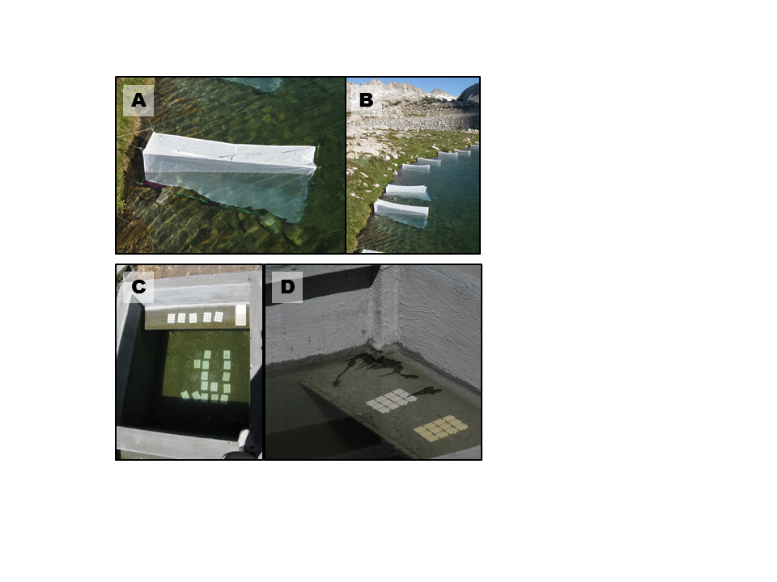

FIG. 1. A and B) Field enclosures in LeConte lake in Kings Canyon National Park, C and D) mesocosms located at Sierra Nevada Aquatic Research Laboratory in Mammoth Lakes, CA.

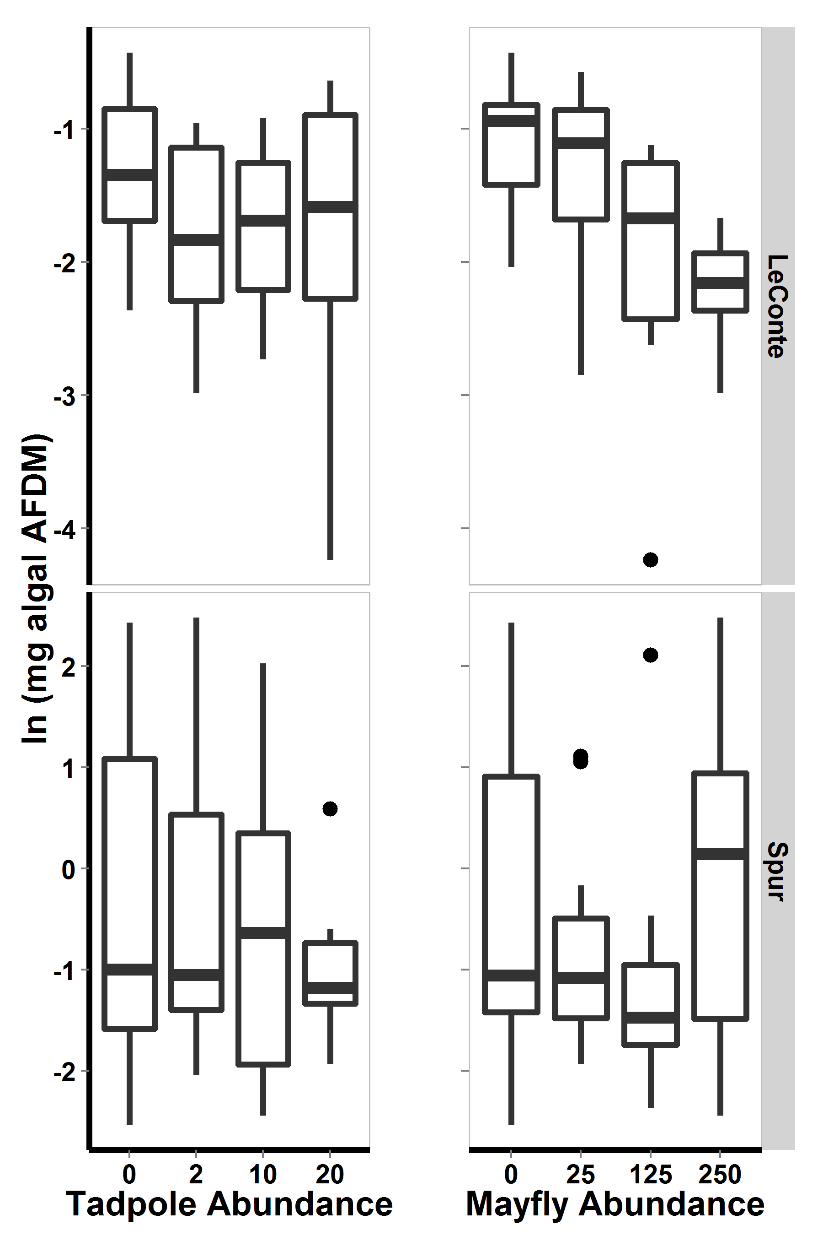

Figure 2. For 2009 field enclosure experiment, algal abundance with respect to lake and to each consumer. Bars show medians, boxes include 50% of the data, and whiskers include 95% of the data.

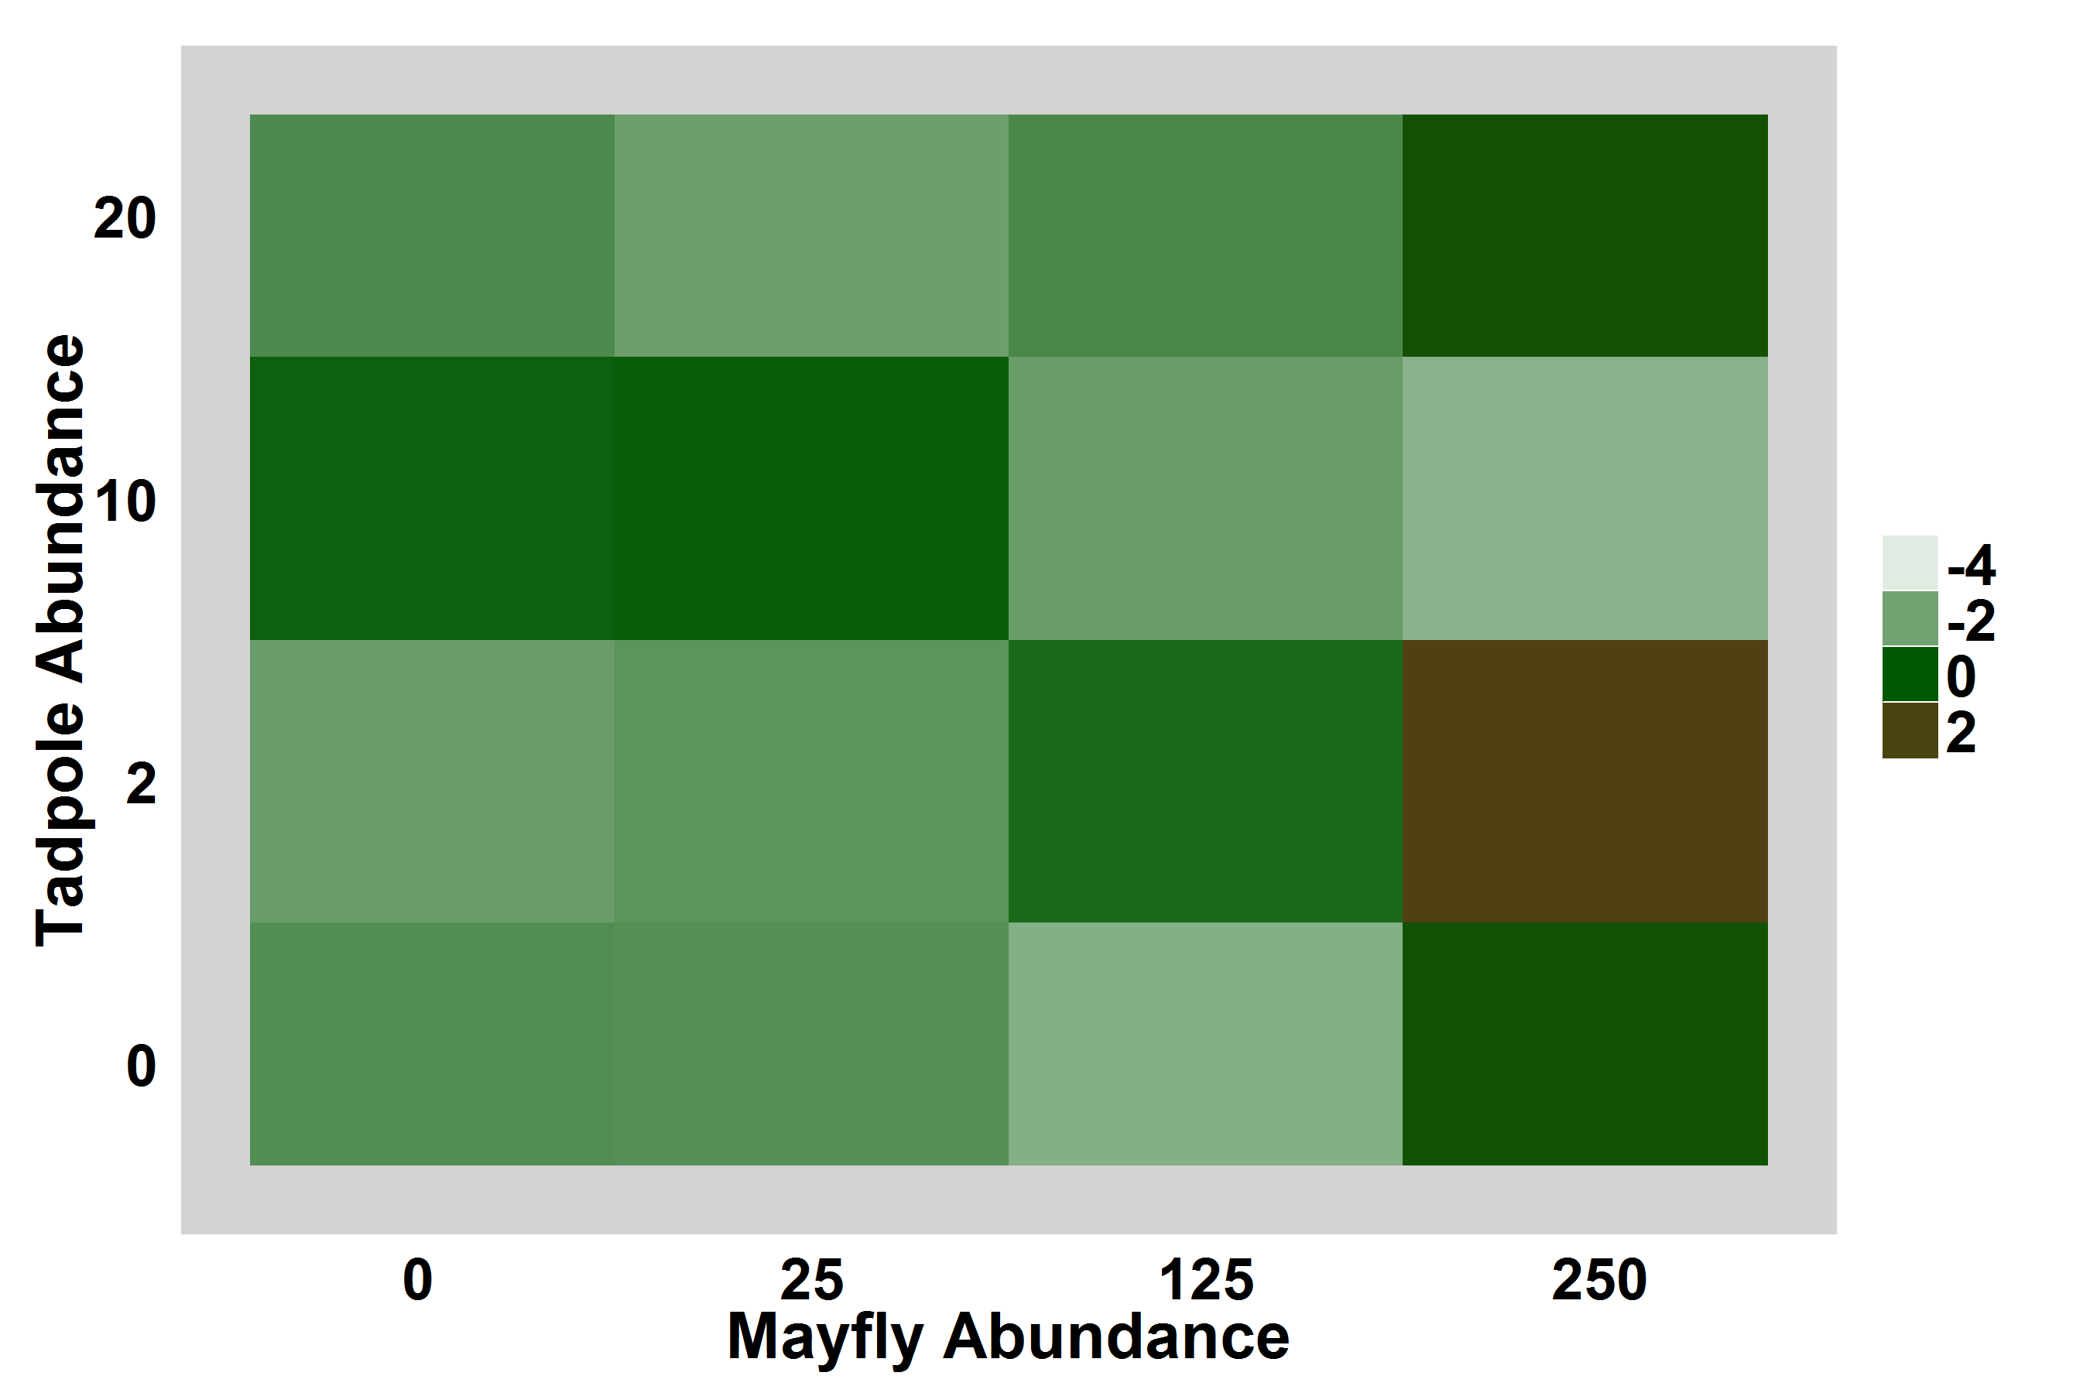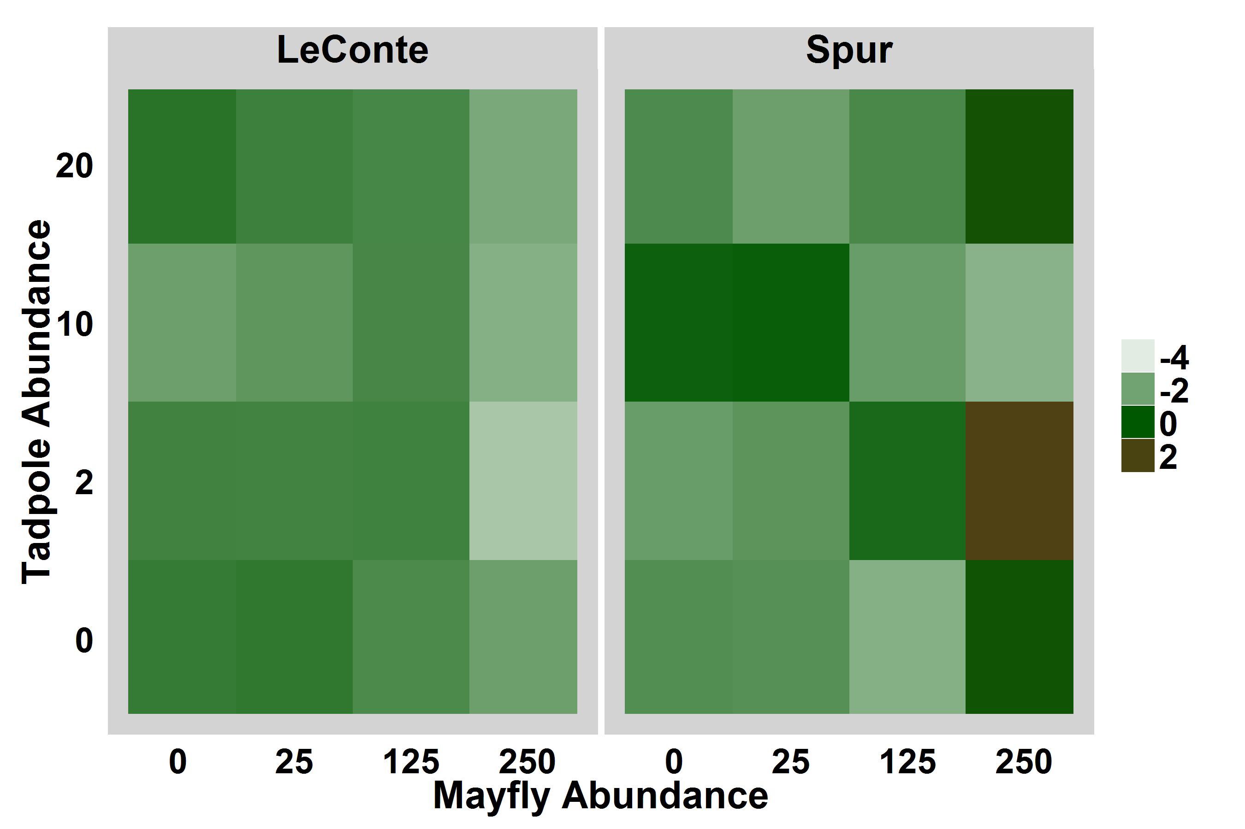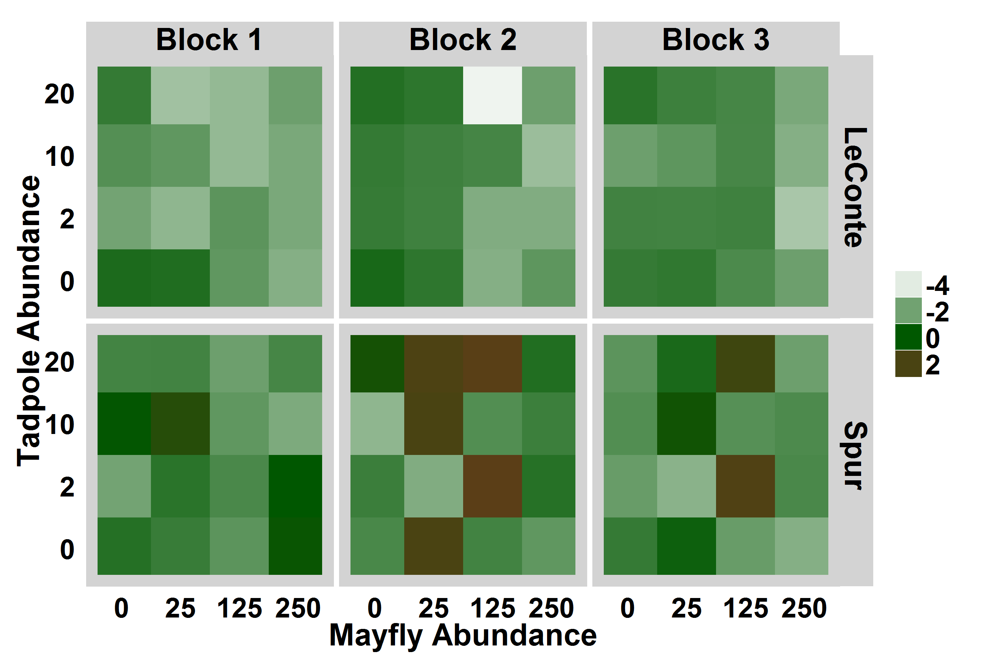

Figure 3. For 2009 field enclosure experiment, heat map displaying log-transformed algal abundance with respect to consumer densities and lake, averaged over experimental blocks. Brown indicates high algal abundance.

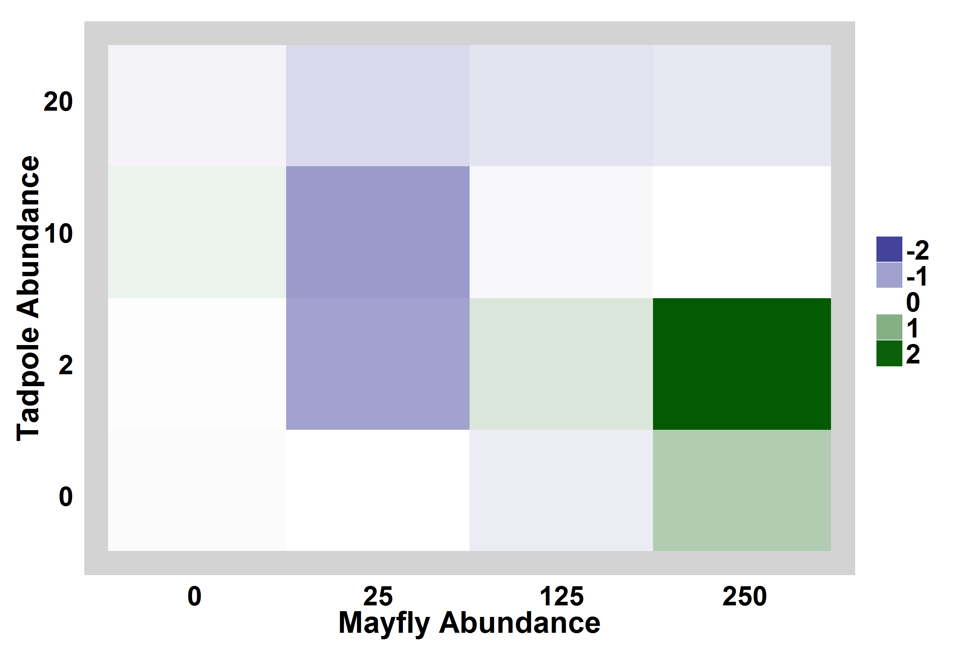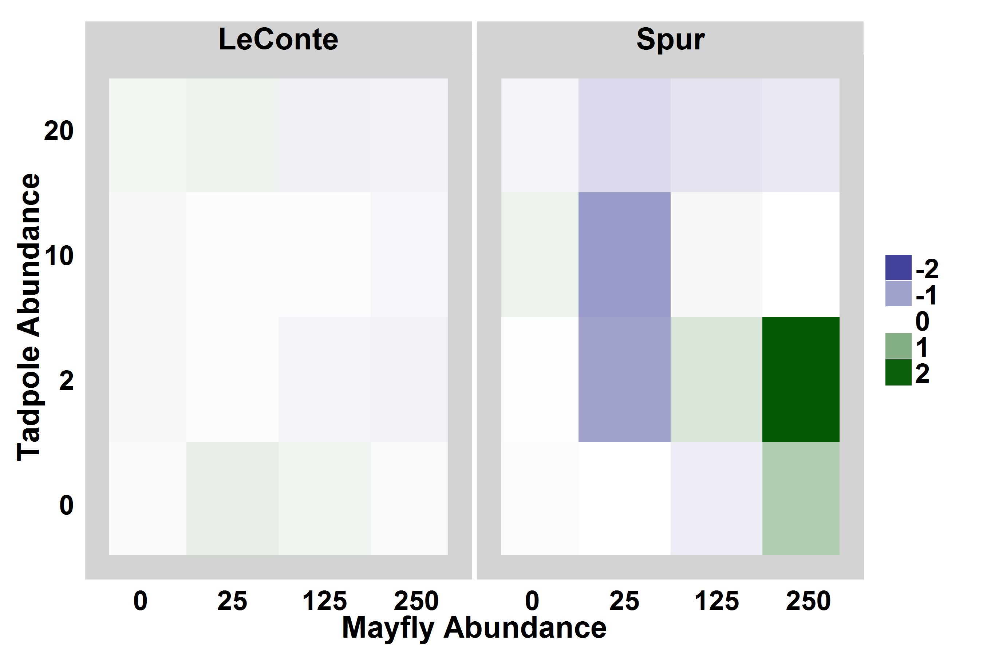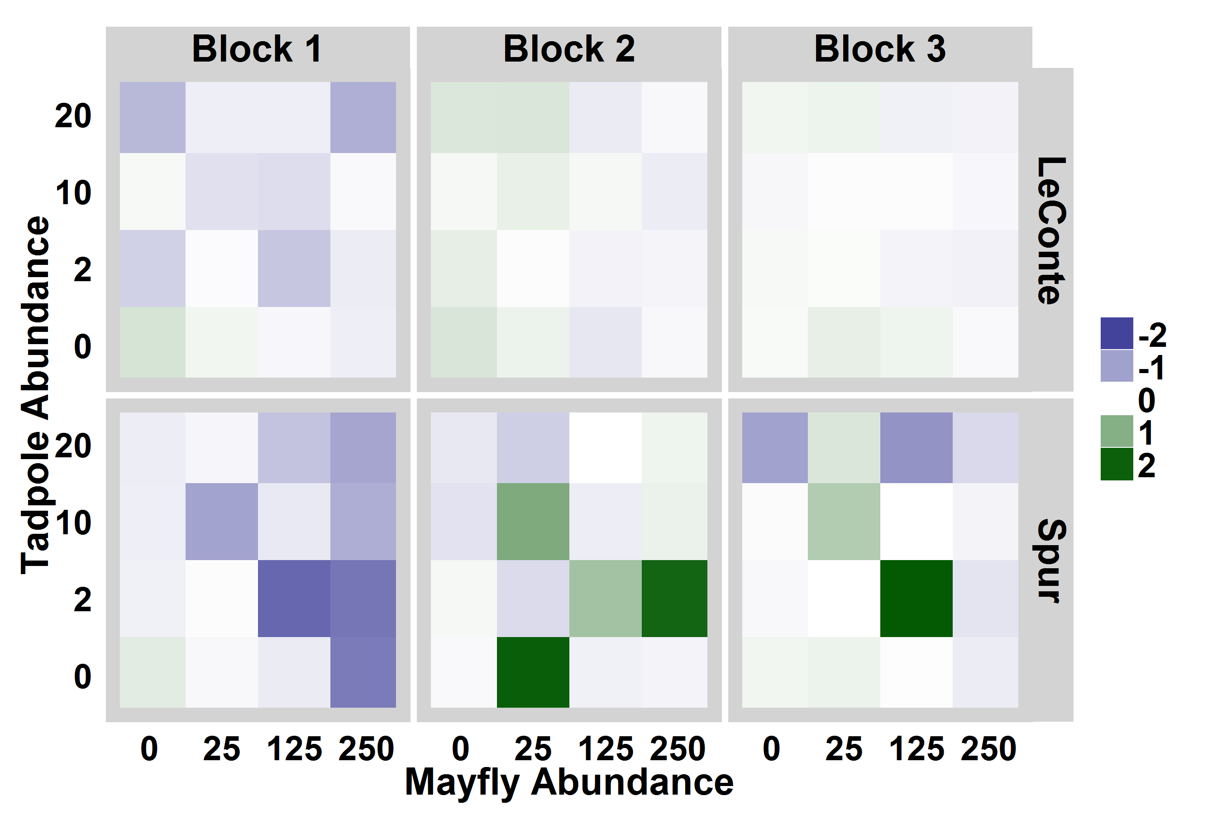

Figure 4. Heat maps showing algal abundance in each enclosure relative to within-lake-location controls. Bluer colors indicate that algal abundance was lower in the enclosure than in the control, i.e. consumers reduced algal abundance, while greener colors indicate that algal abundance was high in enclosures relative to controls. For display purposes, the relative algal abundance was log-modulus transformed.

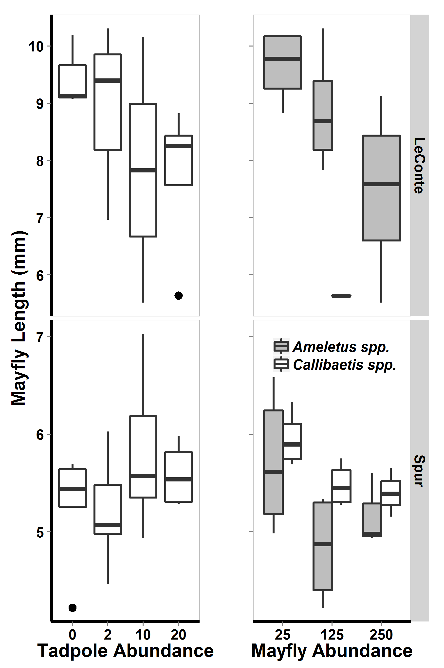

Figure 5. For 2009 field enclosures, mayfly lengths (mm) with respect to tadpole density and to mayfly density. Note difference in mayfly length scales between lakes.

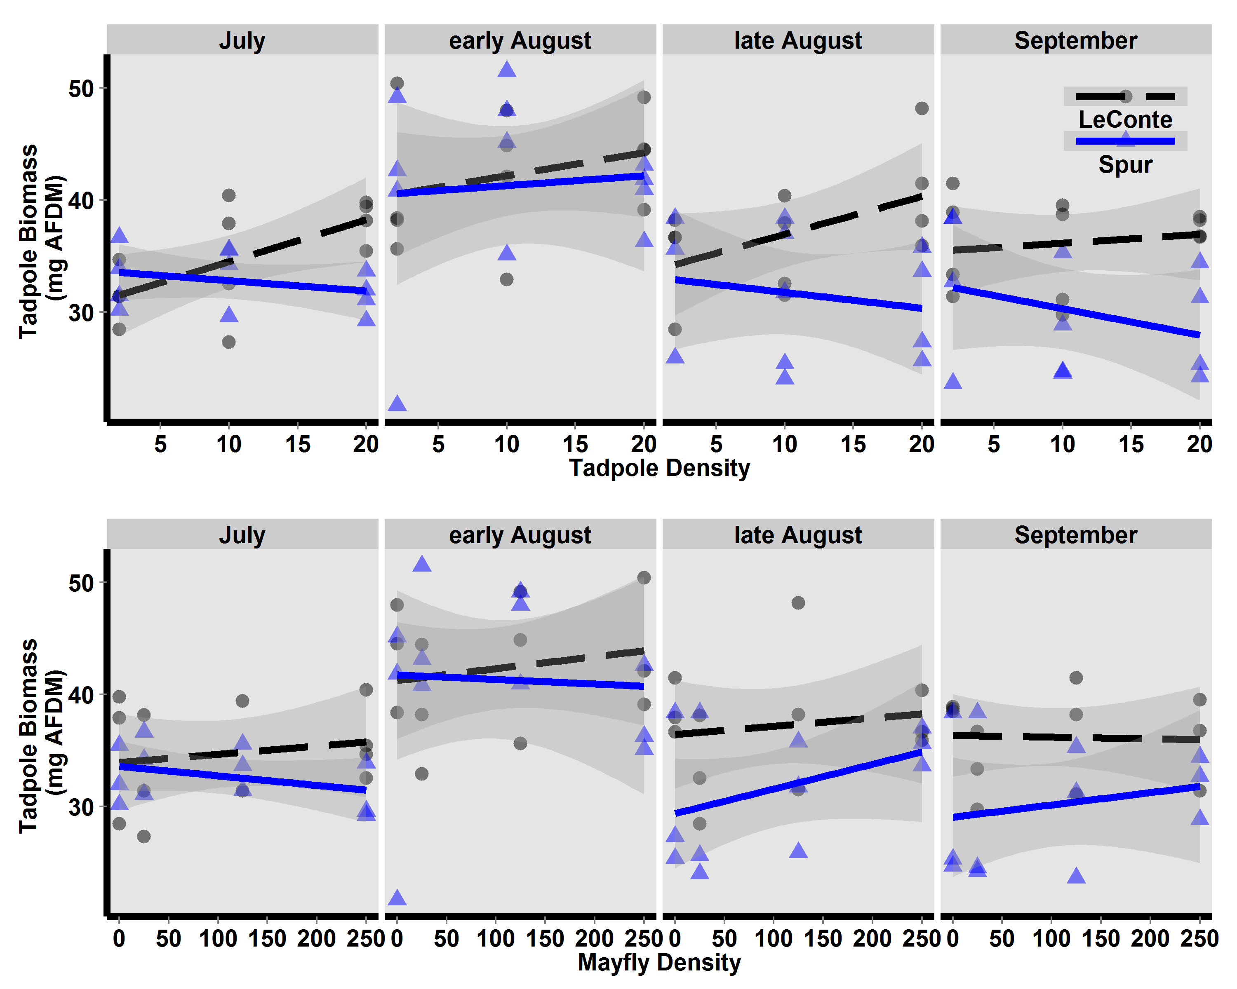

Figure 6. For field enclosures, estimated tadpole AFDM (mg, based on Gosner stage-AFDM regression) with respect to tadpole density (top) and mayfly density (bottom).

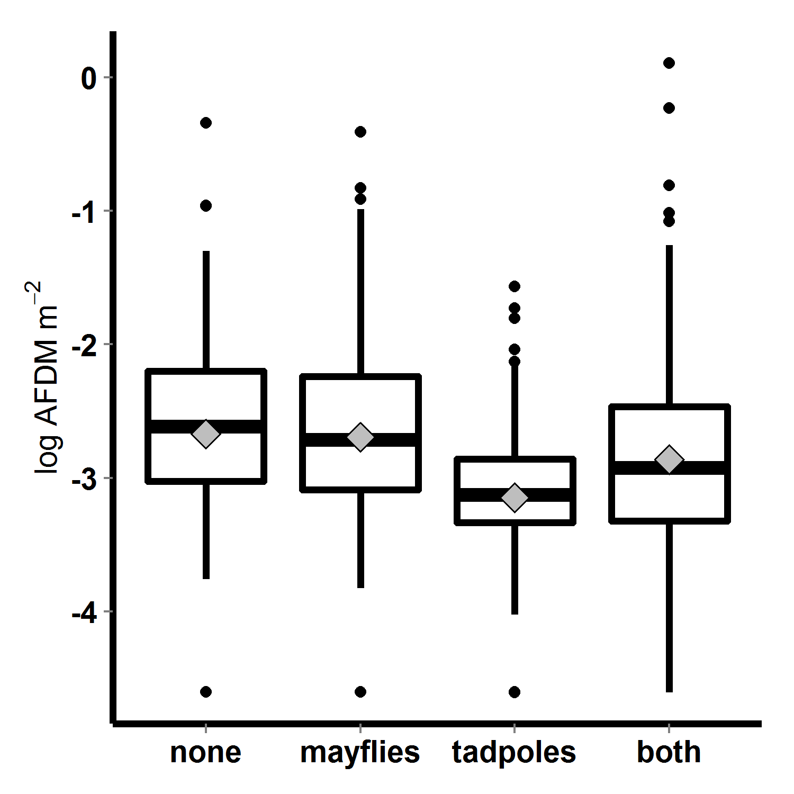

Figure 7. Algal abundance (log transformed AFDM) in 2010 mesocosms, with respect to tadpole and mayfly treatments; bars indicate medians, boxes contain 50% of data, whiskers contain 95% of the data, points are outliers, and diamonds indicate means.

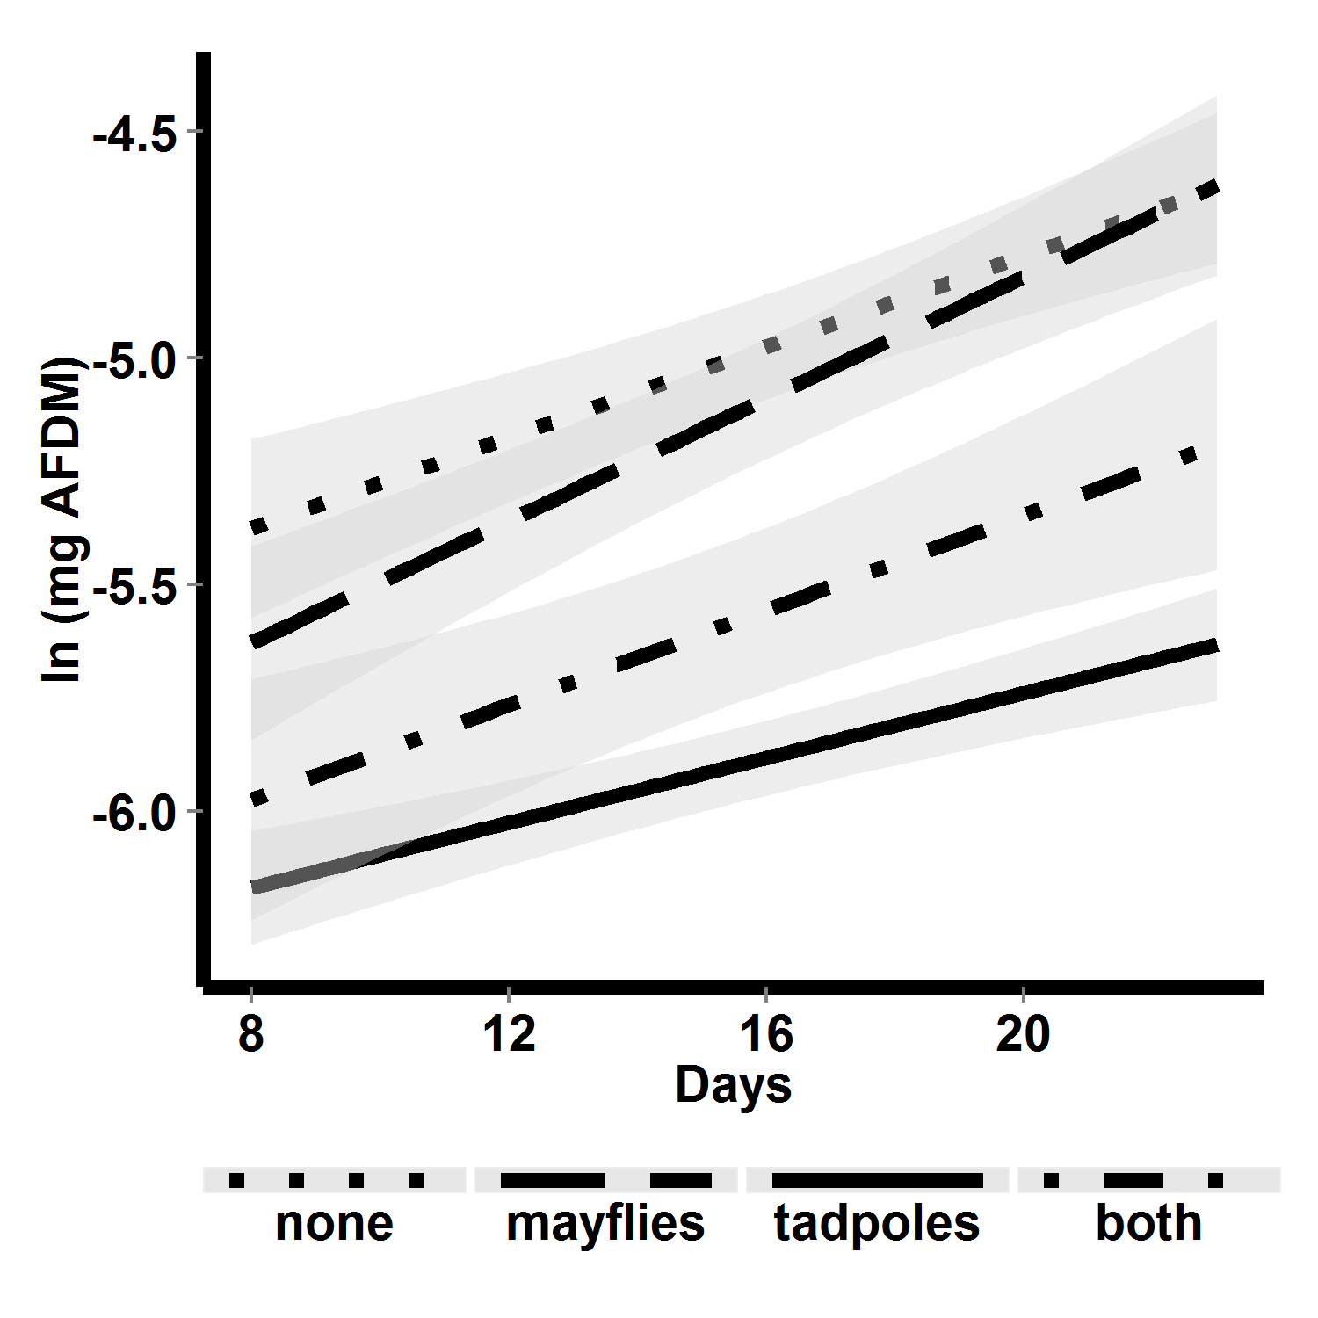

Figure 8. Algal abundance over time in 2010 mesocosms, with respect to consumer treatment. Lines are linear fits, and shaded areas are 95% confidence regions for those fits.

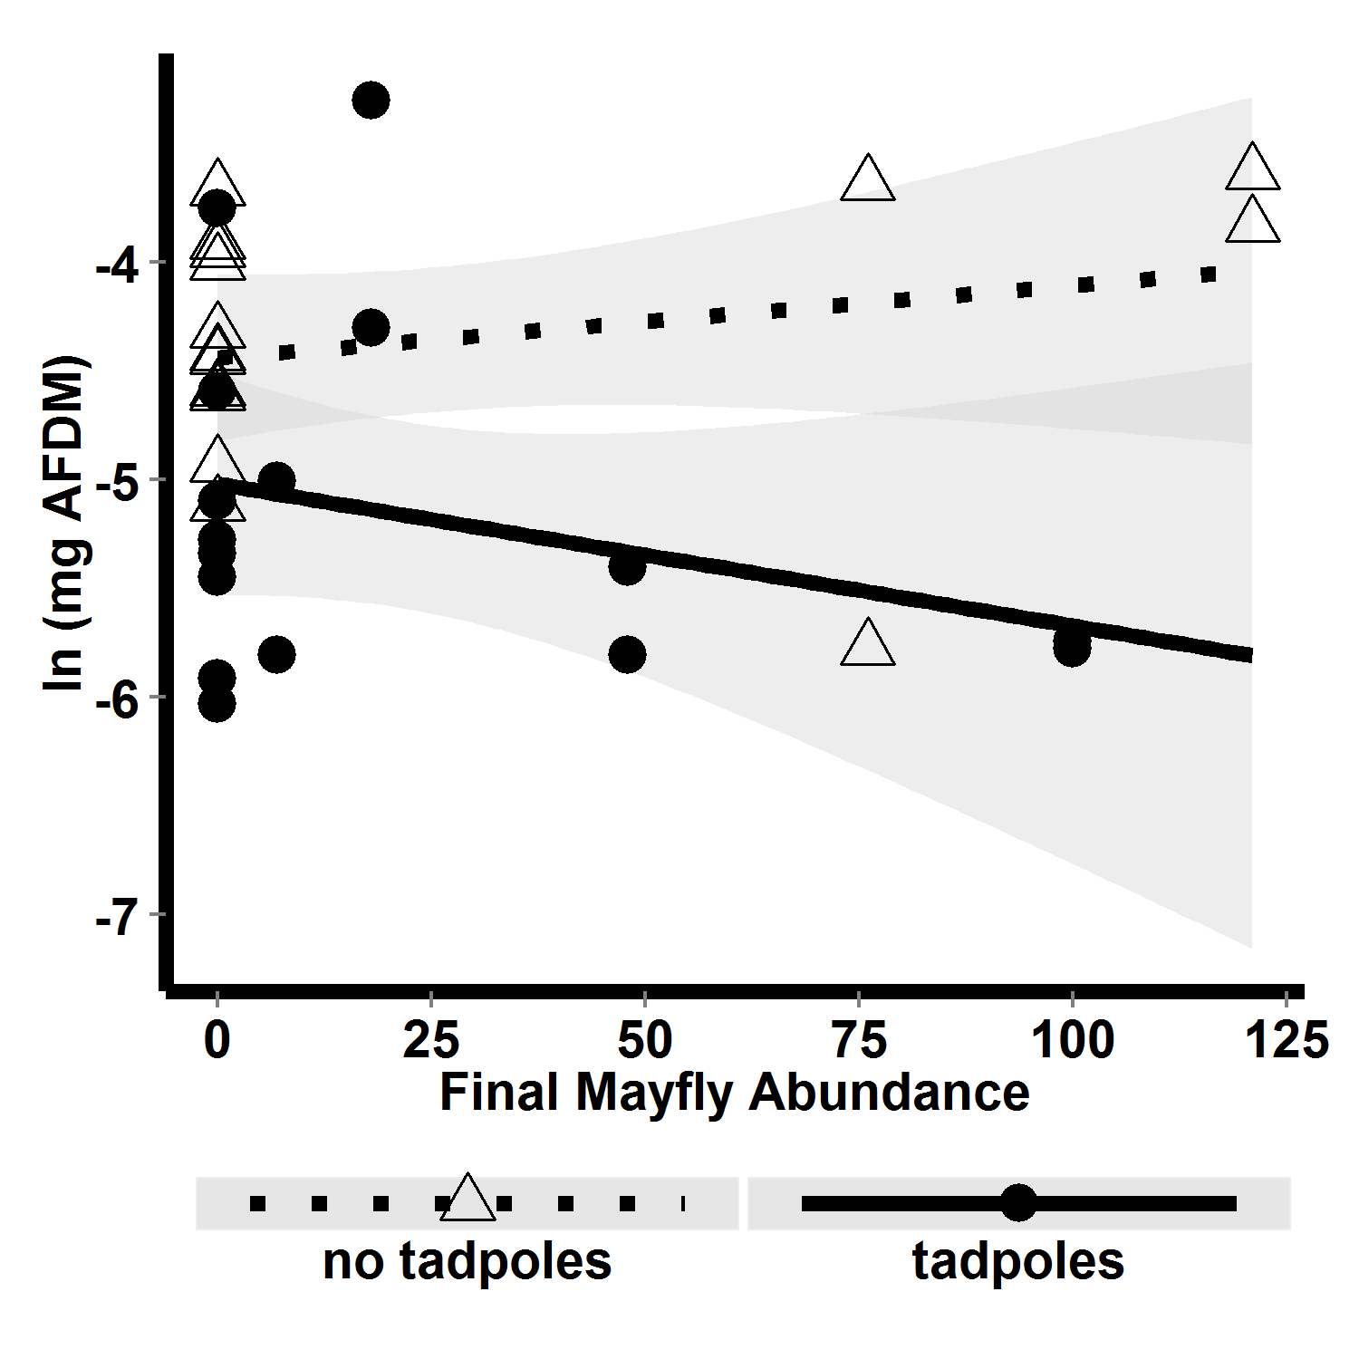

FIG. 7. Algal abundance with respect to interaction between final mayfly abundance and tadpole presence absence.